LOMA and DAVA ASSIGNMENT

PART 1

AY2021/2022 Apr Semester

DECLARATION

I declare that I am the originator of this work and that all other original sources used in this work have been appropriately acknowledged.

I understand that plagiarism is the act of taking and using the whole or any part of another person’s work and presenting it as my own without proper acknowledgement.

I also understand that plagiarism is an academic offence and that disciplinary action will be taken for plagiarism.”

I Agree (Please Tick )

My Information
Name (as in matriculation card) | Chong Siang Nathan
Admin Number | 21000704B
Class (E.g. T01) | T14

LOMA – Total Hotel Charges

1. You are assigned to work out the total charges (inclusive of GST and service charge) for one booking in the dataset.

Answer:
My matriculation number is : 2100704B
Therefore, the booking number I work on is : 704 + 1000 = 1704
adr = 36 , stay_in_weekend_nights = 1 , stay_in_week_nights : 3
The Length of stay is : 4
Total before GST and service charges is : 144
Total after GST and service charges is : 169

My working is shown below:
Total length of stay (los) = stay_in_weekend_nights + stay_in_week_nights
= 1 + 3
= 4 days
Total before GST and service charges = 4 x 36
= 144
Total charges inclusive of GST = 144 x 1.07
= 154.08
Total charges inclusive of GST and service charges = 154.08 x 1.1
= 169.488
≈ 169 (nearest integer)
[Be sure to show your step-by-step working.]

2. Using the last two digits of your matriculation number to represent x and y respectively, find the value of k using a calculator (E.g. if your matric number is 2112345A, then use x = 4 and y = 5). Be sure to show your step-by-step working.

Re-compute the total charges inclusive of GST and service charges based on k (new GST rate). Truncate your answer to an integer.

Answer:
My matriculation number is: 2100704B
Therefore, X = 0 and Y = 4
The value of A is : 3
The value of B is : 0.6962
The value of k is : 10
The total after GST and service charges is : 174.24

My working is shown below:
Where x = 0,
A(x) = ⎾ $e^{\frac{3x+10}{10}}$⏋mod 8
= ⎾ $e^{\frac{3 \left(0\right) +10}{10}}$ ⏋mod 8
= ⎾ $e^{\frac{10}{10}}$ ⏋mod 8
= ⎾ e ⏋mod 8
= 3 mod 8
= 3
Where y = 4,
B(y) = log₂₀₀ (2y² + 8)
= log₂₀₀ (2(4)² + 8)
= log₂₀₀ (40)
= $\frac{\log{40}}{\log{200}}$
= 0.6962
k = ⎿ A(x) + B(y) + 7 ⏌
=⎿ 3 + 0.6962 + 7 ⏌
=⎿ 10.6962 ⏌= 10
Total charges before GST and service charge = 144
Total charges after new GST of k% = 144 x (100% + 10%)
= 144 x 1.1
= 158.4
Total charges after service charge = 158.4 x 1.1
= 174.24
≈ 174
[Be sure to show your step-by-step working.]

3a. Is the function one-to-one?

Answer: No. The function is not one-to-one as many values of x in the domain share the same image in the co-domain. Thus, each element in the domain does not have a unique image.
For example, let us take two values of x, x = 1 and x = 27.
Where x = 1, A(x) = ⎾ $e^{\frac{3 \left(1\right) + 10}{10}}$⏋mod 8
= 4 mod 8
= 4
Where x = 27, A(x) = ⎾ $e^{\frac{3 \left(27\right) + 10}{10}}$⏋mod 8
= ⎾ $e^{9.1}$⏋mod 8
= ⎾ $8955.29$⏋mod 8
= 8956 mod 8
= 4
Since both x = 1 and x = 27 share the same image of 4, the image is not unique, so the function is not one-to-one.
3b. Is the function onto?

Answer: Assuming R is the set of all real numbers, the function is not onto.
For example, let us take B(y) = -1.2, which is a negative real number in the set of R.
𝑙og₂₀₀ (2y² + 8) = B(y)
𝑙og₂₀₀ (2y² + 8) = -1.2
2y² + 8 = 200 ^{-1.2}
2y² = 200^{-1.2} – 8
y² = $\frac{{200}^{-1.2}-8}{2}$
= -3.999
Since y² ≥ 0 for all real values of y, so B(y) = -1.2 is not valid. Thus, the function is not onto since not all values of B(y) in the co-domain have a corresponding image in the domain.

4. Explain whether X or Y has a greater influence.

Answer: x has a greater influence. Exponential functions have a much steeper curve than logarithmic functions. Thus, exponential functions have a far greater impact than logarithmic functions.
This is best illustrated by the function below where the blue curve represents 𝑙og₂₀₀ (2y² + 8) and black one⎾ $e^{\frac{3x+10}{10}}$⏋mod 8
Since x and y represent the last two digits of our matriculation number, we shall assume both x and y are integers where 0 ≤ x ≤ 9 and 0 ≤ y ≤ 9. This is reflected In the graph below.
(answer continued on next page)
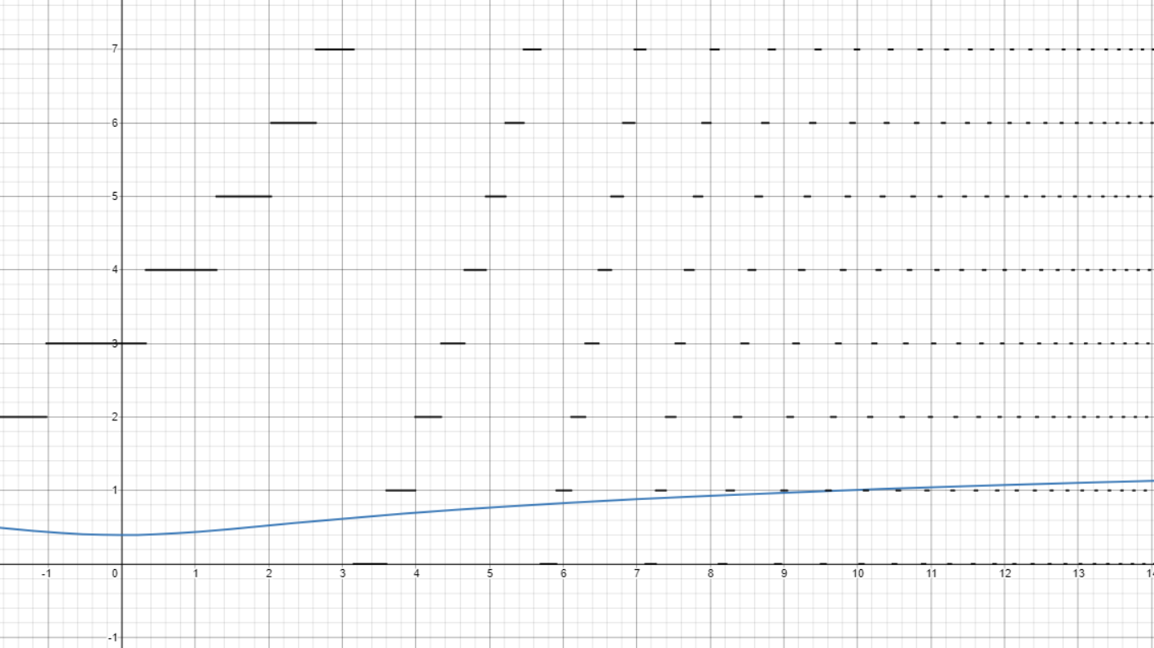
The graph shows that the exponential function causes huge changes in output value with a small change in the value of x. This is in stark contrast to the logarithmic function, where changes in the value of x do not affect the output value by a large amount.
Thus, x has a greater impact on the value of k than y.

DAVA – Truth or Myth?

- The first belief I am investigating is: The higher the number of children, the higher the average for total_of_special_requests. This applies to all customer types.
Conclusion: Based on data, this conventional belief is false.
Justification:
The following image is the result of a bar chart created using the Interactive Histogram node in KNIME, with the average total_of_special_requests in the y-axis and children in the x-axis.
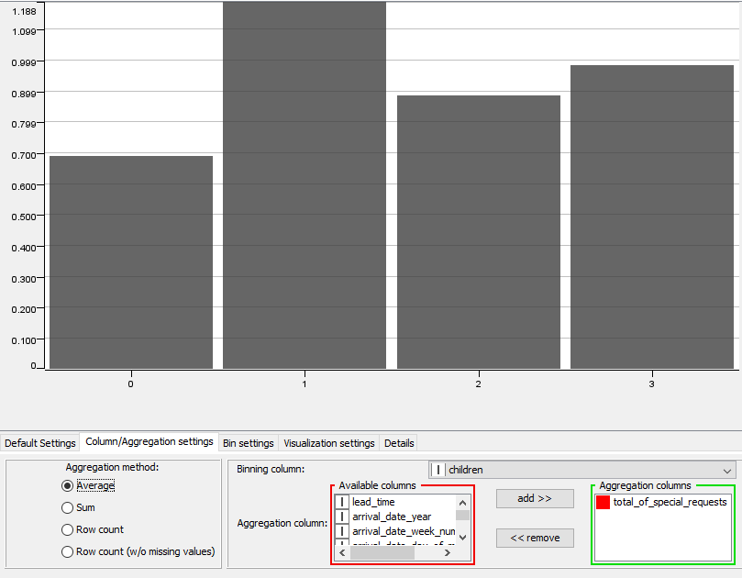
The bar chart shows that the average value of total_of_special_requests is highest when the number of children is 1. The average value of total_of_special_requests is lowest at children = 2 and then increases slightly at children = 3.
In addition, on a scale of 0 to 1, the correlation measure of number of children and the average value of total_of_special_requests is 0.0951, indicating that there is hardly any correlation between the two variables.
Since there is no clear correlation or pattern between the number of children and the average for total_of_special_requests, this belief is false.

- The second belief I am investigating is: The best time of the year to get the cheapest average daily rate (adr) is in January.
Conclusion: Based on data, this conventional belief is true.
Justification:
In order to determine and compare the median, lower quartile and upper quartile of the average daily rate (adr) between months, I have plotted a Conditional Box Plot in KNIME with the nominal column set to arrival_date_month and the numeric column set to adr. Below are the results:
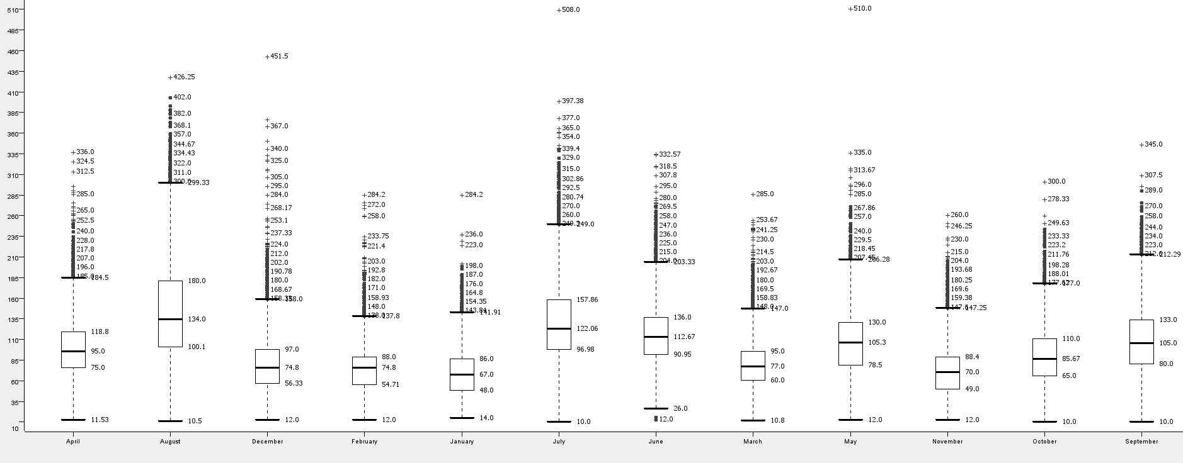
Below is a bar chart of the mean adr against arrival_date_month.
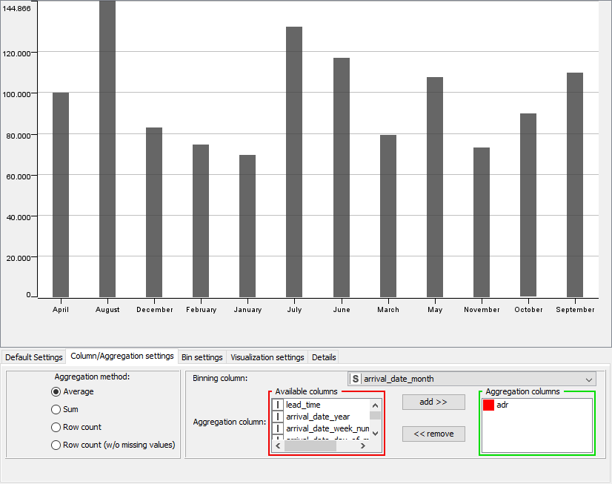
The Conditional Box Plot shows that the month of January has the lowest median, lower quartile
and upper quartile adr. In addition, the bar chart shows the January has the lowest mean adr.
This data supports the belief that January has the cheapest average daily rate (adr).

- The third belief I am investigating is: In terms of market segment, “Online TA/TO” has the highest average lead time as well as the highest proportion of bookings.
Conclusion: Based on data, this conventional belief is false.
Justification:
We assume that the question involves the “Offline TA/TO” market segment, as that segment has the closest naming to the segment named in the question.
I placed a GroupBy node, grouped by market_segment, and aggregated by the mean of lead_time and the count of distribution_channel, then connected an Interactive Histogram to it to better visualise the data.
The bar chart below is binned by market_segment and aggregated by the mean of lead_time. Here we can see that Groups have slightly higher mean lead_time than Offline TA/TO, thus indicating the Offline TA/TO doesn’t have the highest average lead_time in terms of market_segment.
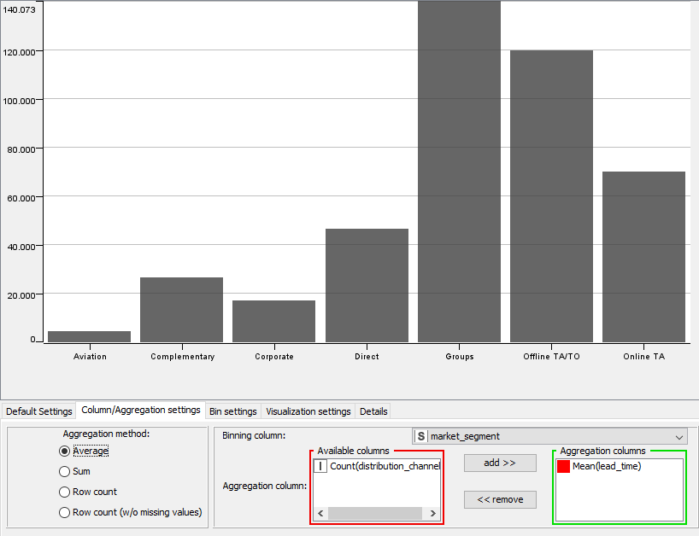
In terms of proportion of bookings, Offline TA/TO is the highest. We can see evidence of that from the bar chart binned by market segment and aggregated by the count of distribution_channel.
As shown from the bar chart, Offline TA/TO has a smaller proportion of bookings compared to Online TA. Thus, Offline TA/TO does not have the highest proportion of bookings either.
In conclusion, the belief is false.

Screenshot of my overall KNIME workflow is shown below.
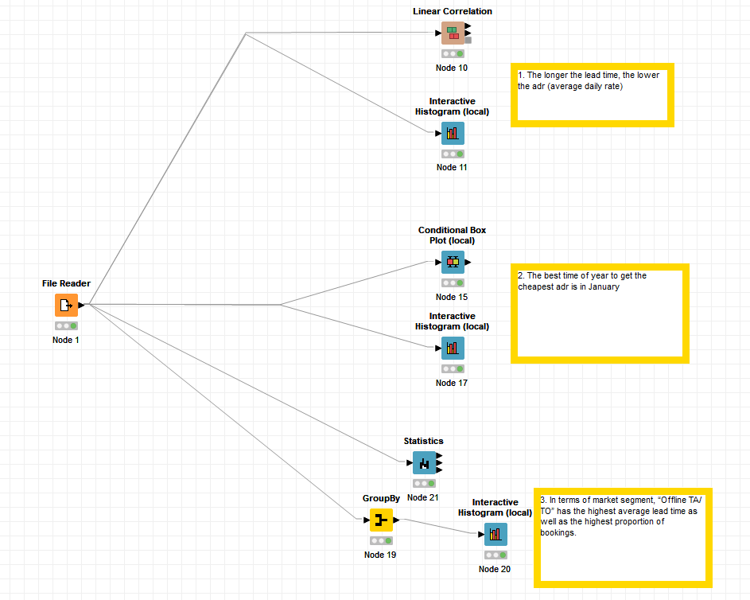

SUBMISSION INSTRUCTIONS

- Save this file as “Assignment_Part1_[Your Class]_[Your Full Name]”, e.g. “Assignment_Part1_T01_Peter Lam”
- Submit your report to LOMA LMS site > Assessment > Assignment >
Look for the appropriate link to submit your work.

***** END OF ASSIGNMENT PART 1 *****

